Description
In this project you have to make a html page which will make an API call (Covid API) that will give the data of the active cases, recovered cases and death cases with following description: -
a) You have to make a form that will have three input
1) You have to take Country name.
2) In second input you have to give the starting date.
3) In the second input you have to give the end date.
b) Validation of the form should be there you cannot submit the empty form. It should generate the alert message if there is an empty field.
c) When you click on submit button the data of the active cases and, recovered cases and death cases from the starting and the ending case should be displayed below the form.

Additional detail
a) There is no restriction on designing but it should be mobile friendly.
b) You have pushed the code on the GitHub with private repo. Please don't make your repo public or you may lose the marks.

Marks Description (Total Score: 20)
- 15 marks for the form designing.
- You can use any suitable tag to display the information.
b) 15 marks for the functionality
c) 5 marks for the styling
- Please use Calibri font style on the button or for the input as well.
- Margin and padding can be adjusted as per own desire, but it should be visually understandable.
- Do not use bright colours otherwise you will not get any scores.

d) 5 marks for the code readability (spacing and indentation should be well maintained in the code)
e) Step marking will be there in the code i.e., in designing if you have implemented specific points correctly, then scores will be allotted to you.

IMAGE 1: SAMPLE DESIGN


There is a three input box the first one is taking the input of the country and the second on is taking the starting date and the third one is the end date .

IMAGE 2: SAMPLE INPUT 1
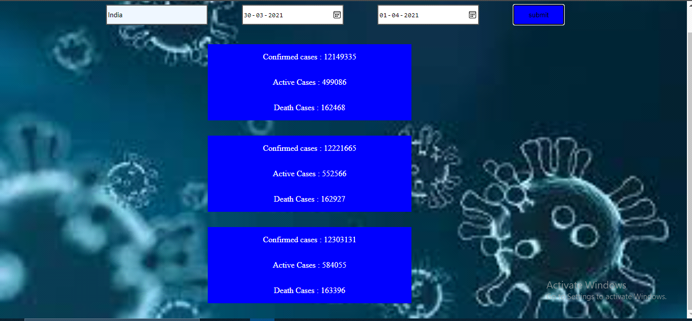

All the data from the starting date and the end date is displayed below the form.

API LInk:-
https://api.covid19api.com/country/${country}?from=${dateOne}T00:00:00Z&to=${dateTwo}T00:00:00Z
eg:-
https://api.covid19api.com/country/south-africa/status/confirmed?from=2020-03-01T00:00:00Z&to=2020-04-01T00:00:00Z

